Problem Statement for Individua Project

Student Name: Ming-Chang Chiang

This article , [America’s unique gun violence problem, explained in 17 maps and charts](https://www.vox.com/policy-and-politics/2017/10/2/16399418/us-gun-violence-statistics-maps-charts) ,discusses gun ownership in the U.S., showing the correlation between gun and suicide and comparing guns and homicide rate in the U.S. versus the rest of the world. The author uses various resources, such as maps, charts, and academic researches to tell the whole story. What the author wants to do is to convince the readers that the number of guns own by people is highly correlated to suicide and homicide rates, and gun violence in the U.S. is worse than other developed countries simply because Americans have more guns and can access guns more easily than people in other countries.

The author wants to use data visualization and research to convince the readers that the number of guns that Americans have is highly correlated with firearm homicides. For example, the author points out that the U.S. didn't not have the worst crime rates, either violent and nonviolent, among 15 industrial countries in the year 2000 by using Gallup Europe’s survey result. However, the homicide rate in the U.S. was three times more than the homicide rates in all other countries in 2012 by referencing economist Richard Florida’s research. From here, we can see author use data in different year which may not be very comparable.

The first thing I like about this article is the author collected abundant resources and cited the research from world renowned institutions, such as Harvard, Duke and Berkeley. Those references somewhat make the article more convincing. Secondly, I appreciate the author used 17 graphs to convey his idea, and in almost every graph, besides Graph 6, author had some texts to explain those graphs. This way, readers can know how to interpret the graphs and gain more background knowledge and reference. The third thing I liked is that the author covered very broad issues related to gun, including gun death, gun right policy, mass shooting, firearm suicide, and homicide.

Although the author collected lot of information, there are some issues that make this article not so convincing. For example, in Graph 6 of the article (see graph to the below left), the author did not provide much explanation, so readers don't know how or why these countries were selected. I consider the author might select these countries with the intention to prove that the number of gun per 100 people is highly related to gun death. After some research, I found another writer collected the same information for other countries and put in the same graph. This graph shows that those countries with lower gun per 100 people than US actually have higher gun death rates. Please see graph on the below right.[1]



Another thing that makes this article ineffective is on the map presented in Graph 3 below. There were many red dots across the U.S., which showed the mass shooting happening in different places in the U.S. since Sandy Hook mass shooting in 2012. However, the author didn’t provide the definition of the light red and dark red dots, thus the readers need to guess at the meaning of the color shades. I had guessed that the different color shades represented the different numbers of people wound or died in a mass shooting. A better way to redesign this graph is to use two bar charts to describe the amount of mass shooting and amount of people killed or wounded in different states.



For all the graphs in this article, we see the graphs are made in different time frame. This makes it difficult for readers to align all the information together and results in logical fallacy. Worse yet, there are some graphs showing no information on the data period. Another thing that make these graphs less effective is that the author used out-of-date statistic in some graphs, such as in Graph 8, the date of information is 2007. Since the article was published in 2018, it will be more effective and convincing to put more recent data. Below is the table that summarizes time frame presented in each graph.

|  |  |
| --- | --- |
| Graph Number | Data Period |
| 1 | 2012 |
| 2 | Not provide. I found the data should be 2007 |
| 3 | 2017 |
| 4 | 2015 |
| 5 | 2013 |
| 6 | Not provide. |
| 7 | 2000 |
| 8 | 2007 |
| 9 | 1981~2010 |
| 10 | 1999~2016 |
| 11 | 2001~2015 |
| 12 | 1990~1997 |
| 13 | 1907~2006 |
| 14 | Not provide. |
| 15 | 2000~2017 |
| 16 | 2012 |
| 17 | 2017 |

Since the timeframe of the data is not consistent, some readers might be concerned that the author is cherry-picking specific timeframes that fit his point of view. For example, in Graph 4, the author said there was approximately one mass shooting in America every day. The graph shows the number of mass shooting per day in 2015. For years other than 2015, we might see different results that differ from the author’s point of view. The same argument can be applied to Graph 1, 3, 4, 6, 7, 8, 12, 13, 14 and 17.

Besides the timeframe issue, the practice to design the graph can be improved and made consistent in this article. I found that all 17 graphs in the articles were screenshotted from different sources, so the styles and format of the graphs are not consistent. Having many different types of graph in one article makes it difficult for readers to organize and understand the key concepts. Readers are unlikely to read the entire article and remember the ideas that the author wanted to convey. Below are two graphs from the article to show the different style of the graphs. Both graphs are scatter plots, but they have different background color (i.e., yellow vs. white), and only one graph has guide lines.

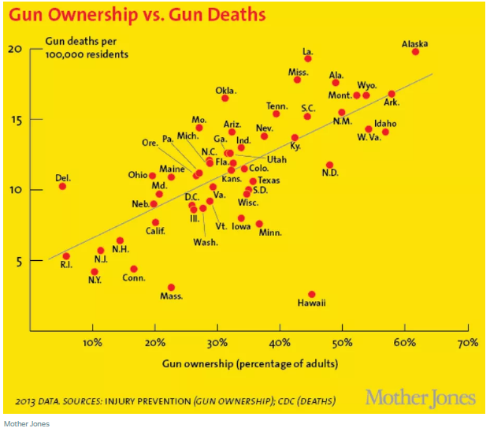 

**Proposal to redesign the data product**

To redesign the data product, my first step will be collecting all the dataset that the author used. I would like to use the data in the similar timeframe. For example, all the tables and graphs would show a single year information in 2017. For those graphs with consecutive year information, the ending year would be in 2017.

My second step will be choosing a powerful visualization tool, either Python, R ,Excel, or Tableau, to reproduce all the graphs. The purpose is to keep consistency in the form of chosen chart across the entire series so that comparisons are easily made, and patterns can be clearly discerned. For example, there would be consistency in labeling method, position, color schemes, and sizes.

The third step is to reproduce all the graphs with the best practice. The best practice is to figure out a methodology that can ensure consistent quality of the visualization work. For example, to define which type of chart is suitable for typical kind of data and analytical purpose. To be more concrete, the simple principle for visualization is using the line charts for tracking trends over time, bar charts to compare quantities, and scatter plots for joint variation of two data items and pie charts to compare parts of a whole.

A simple prototype is to redesign Graph 1 in the article, which requires the reader to spend more time to scroll on a computer to compare homicides rates in different countries. I suggest using simple bar chart, which is easier for readers to see the U.S. has the highest firearm homicide among other countries.

Moreover, I want to make the graphs to be interactive with readers, such as using animation and allow the readers to choose the timeframe they want to look at. The interactive process can help readers understand gun related issues more clearly and is more relevant. For example, instead of just putting one map of the U.S. with red dots showing mass shooting, I plan to create a new map that allows the reader to choose any state. Readers can choose the state they live and get clearer idea about trend and events in their specific locations. This will be helpful to turn readers’ awareness into some strategic actions.

**Data Source:**

**1.**Gun homicides and gun ownership listed by country <https://docs.google.com/spreadsheets/d/1chqUZHuY6cXYrRYkuE0uwXisGaYvr7durZHJhpLGycs/edit#gid=0>

2. Gun Violence Archive, a database that tracks events since 2013 in which four or more people (not counting the shooter) were shot at the same general time and location.

<http://www.gunviolencearchive.org/>

3. USA Mass Shootings Data – from 2014 to 2018.

<http://www.gunviolencearchive.org/mass-shooting>

4. Gun ownership and social gun culture

<http://injuryprevention.bmj.com/content/22/3/216>

5. National Center for Health Statistics :Firearm Mortality by State

<https://www.cdc.gov/nchs/pressroom/sosmap/firearm_mortality/firearm.htm>

6.ICVS - International Crime Victims Survey

<http://www.unicri.it/services/library_documentation/publications/icvs/data/>

7. Guns and Suicide in the United States , Matthew Miller, M.D., Sc.D., and David Hemenway, Ph.D. September 4, 2008

8. Fatal Injury Reports, National and Regional, 1999 - 2015

<https://webappa.cdc.gov/sasweb/ncipc/mortrate10_us.html>

9.Firearm Prevalence and Homicides of Law Enforcement Officers in the United States

<https://ajph.aphapublications.org/doi/full/10.2105/AJPH.2015.302749>

**Reference**

1. Vox’s misleading gun death graph by Jonathan Andreas, October 3, 2017

<https://medianism.org/2017/10/03/voxs-misleading-gun-death-graph/>

2. The Geography of Gun Deaths by Richard Florida ,January 13, 2011

<https://medianism.org/2017/10/03/voxs-misleading-gun-death-graph/>

1. (medianism.org by Jonathan Andreas)